LEGISLATIVE BULLETIN SEPTEMBER 2021

I am Nancy Moses and will be your 2021-22 Legislative chair. We can learn and promote this program together and have some fun along the way.
Your one voice can have a powerful impact when combined with other Auxiliary members. It is so important for you to contact your Senators and Congressmen regarding Veterans bills. The American Legion has a Legion Legislative Action Center that makes understanding Legislation and putting your voice behind it EASY. It is imperative that you follow the steps below. Contact me if you have issues and I can try to assist.
ACTION NEEDED:
- SIGN UP FOR LEGISLATIVE ALERTS by going to the Legion Legislative Action Center. https://www.votervoice.net/AmericanLegion/home

- SEND AN EMAIL TO YOUR REPRESENTATIVE: Two very important issues are being voted on at the house. Go to https://www.votervoice.net/AmericanLegion/home and enter your zip code under Find your Officials. (There is also a cheat sheet with the website addresses and counties our Representatives cover attached.) SEND ME the confirmation email you receive from your representative at brotherton42us@yahoo.com.

- LIKE our ALAKyLegislative facebook page.

We can create a Kentucky Tidal Wave by doing this one simple thing.
H.R. 2190: Helping Homeless Veterans Act of 2021
Helping Homeless Veterans Act of 2021 This bill permanently extends the following Department of Veterans Affairs programs and services: * homeless veterans reintegration programs, * financial assistance for supportive services for very low-income veteran families in permanent housing, * a grant program for homeless veterans with special needs, * treatment and rehabilitation for seriously mentally ill and homeless veterans, * housing assistance for homeless veterans, and * the Advisory Committee on Homeless Veterans. Still waiting to be voted on in the House. (Veterans’ Affairs Committee)

Still waiting to be voted on in the House. (from the Veterans’ Affairs Committee)
H.R. 2419: Affordable Housing for Homeless Veterans Act of 2021
To amend title 38, United States Code, to expand and extend Department of Veterans Affairs assistance for homeless veterans, and for other purposes.

HOW TO SIGN UP FOR LEGISLATIVE ALERTS:
https://www.votervoice.net/AmericanLegion/home
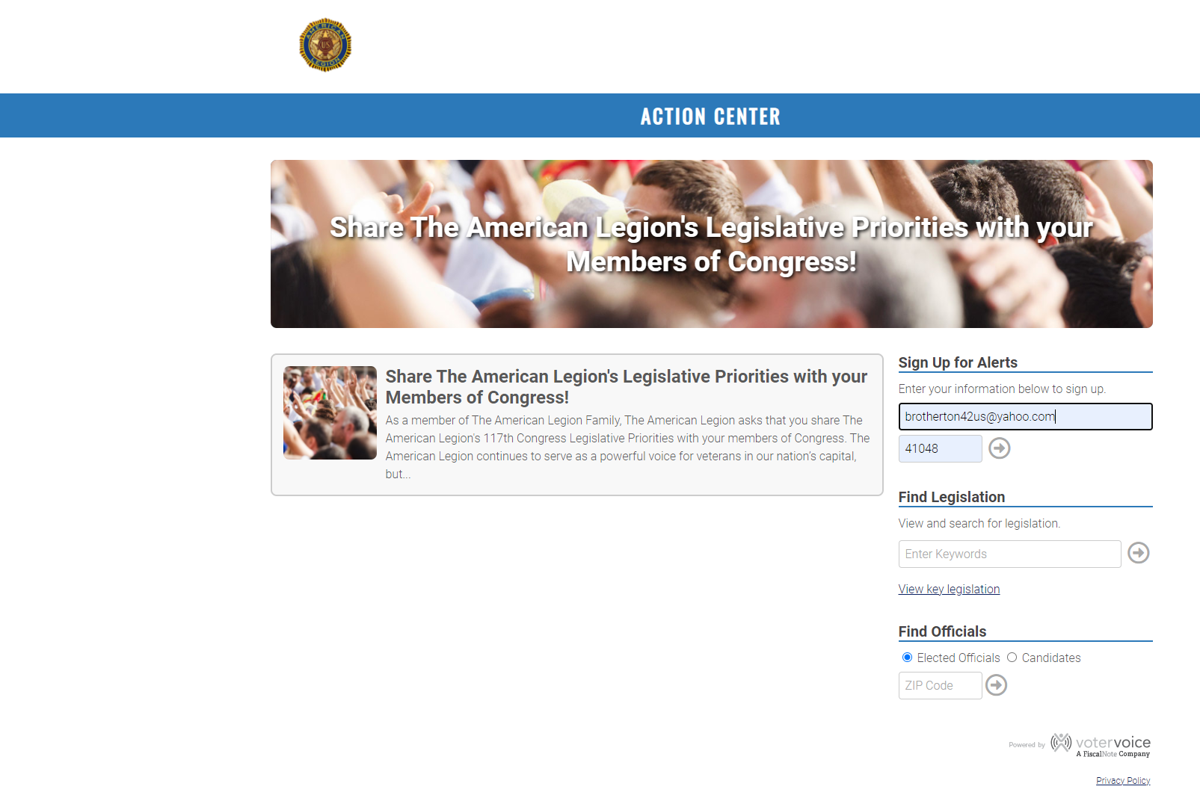
SEND AN EMAIL TO YOUR ELECTED REPRESENTATIVE
The website will ask you for your zip code and address.

It displays who your officials are. In this case click on the Representative listed. (There is one for your specific locale.)
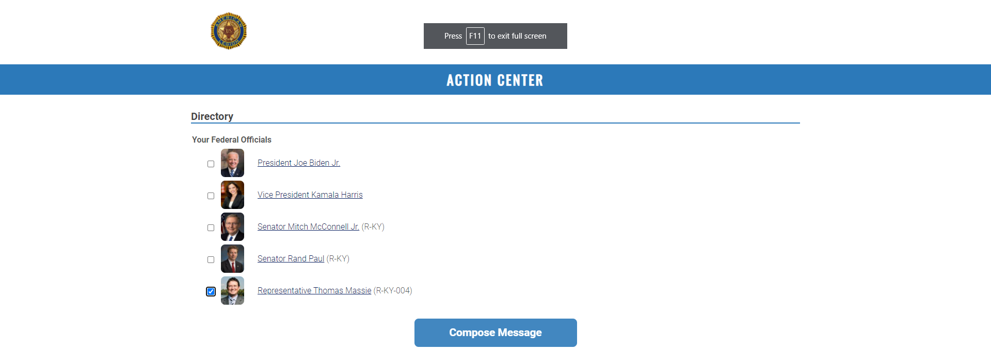
Select your representative and click Compose Message.

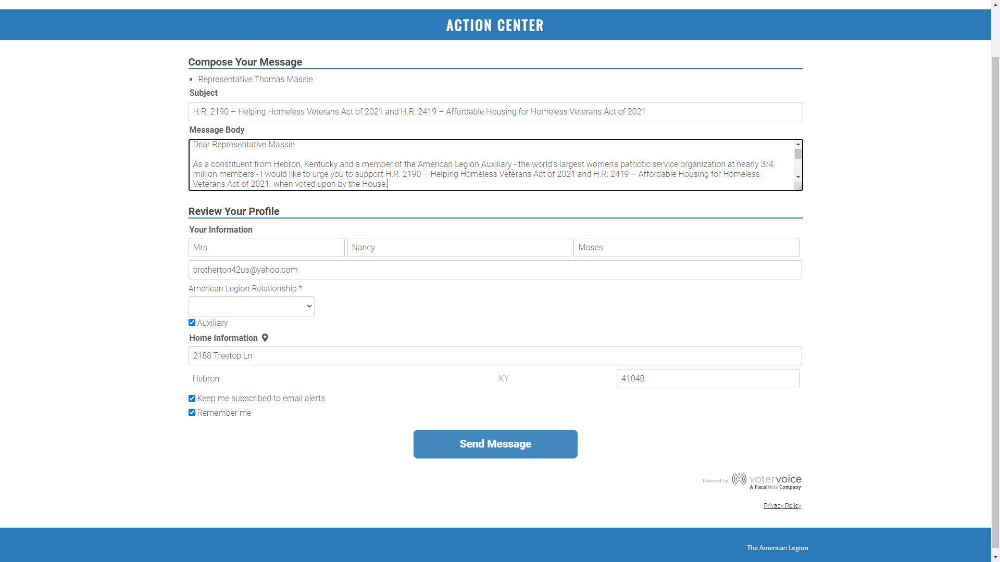

Complete your message and click Send Message.

SAMPLE MESSAGE (depending on the request):
Dear Congressman Massie
As a constituent from Hebron, Kentucky and member of the American Legion Auxiliary– I urge you to support H.R. 2190: Helping Homeless Veterans Act of 2021 and H.R. 2419: Affordable Housing for Homeless Veterans Act of 2021 as it is brought to the House floor to vote.
Thank you for your service to our country and for your service to us in Kentucky. I request a response to this correspondence.
Nancy Moses
American Legion Auxiliary, Kentucky, Unit 4

ONLINE CONFIRMATION MESSAGE is displayed and also to your email address.

FORWARD the EMAIL response to brotherton42us@yahoo.com.
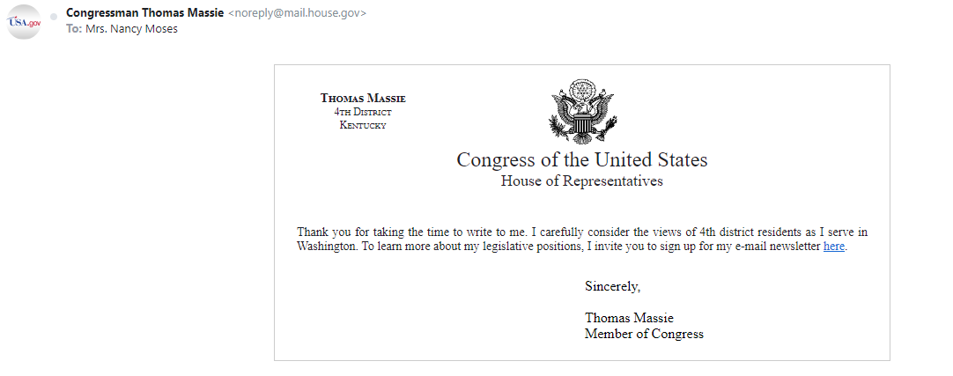
Thank you!

Nancy Moses
2188 Treetop Lane
Hebron, KY 41048
859-630-7941
brotherton42us@yahoo.com

